**Exploring the semi-annual stock price performance after implementing ESOP (Employee Stock Ownership Plan) by listed company Shenzhen Sunsea Communication Company in Chinese A-share Market**

Cara You

*International College Beijing*

*China Agricultural University, Beijing, 100083, P. R. China*

**Abstract**

ESOP was first invented by Louis Kelso in 1956 in the United States to offer stocks as income for the employees when they retired. Now, ESOP is a popular long-term investment project among listed companies in the United States that benefits numerous companies as well as employees. The author is curious about whether the recently released ESOP in China has a similar positive effect on the listed companies in the A-share market. Thus, the paper chose the stock price as an indicator of the market performance and chose Shenzhen Sunsea Communication Company as the target ESOP company in the Chinese A-share Market to discover the development of the weekly return on investment (ROI) of the semi-annual stock price performance after the implementation of an ESOP by listed company.

**Keywords**: ESOP, stock price, semi-annual, price performance, listed company, communication

**Introduction**

ESOPs can be found in all kinds of sizes of companies. Companies with ESOP and other massive scaled employee ownership plans take up of over half of Fortune Magazine's "100 Best Companies to Work for in America" list year after year (ESOP (Employee Stock Ownership Plan) Facts 2017). From the National Center for Employee Ownership’s estimation (2017), there are around 7,000 ESOPs covering about 14 million employees.

An ESOP is a bilateral advantage for both the employees and the company. In terms of the employees, an ESOP offers them a tax-break as well as an income source after their retirements. For the company, ESOP forces

employees to save money in the company, therefore, provide a financing method for the company in the long term. More importantly

ESOPs motivate employees to stay longer (if the employees want to earn long term returns from ESOP) and work harder, which promote the company’s market performance that can be measured through the stock price in the long term (Chiu, W. C. 2003).

Compared to the long history, popularity, and reputation of ESOP in the United States, ESOP was not introduced to China until June 20th, 2014. The positive effect of ESOPs has not been fully recognized and accepted yet (Chiu, W. C., Huang, X., & Lu, H. L. 2005). In order to raise the awareness about ESOPs among investors as a long-term investment method in China, and discover whether ESOPs have similar positive effects on Chinese listed companies via investigating on the change of the semi-annual stock price performance after the implementation of an ESOP by the listed company Shenzhen Sunsea.

**Methodology**

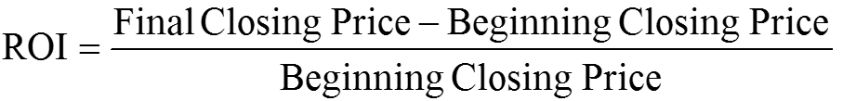The author set the research period from Dec 9th 2016 to June 2nd 2017, and chose to use every Friday closing price during this period to compute the absolute ROI of the targeted company: Shenzhen Sunsea Communication Company.

Shenzhen Sunsea Communication Company offers energy saving solutions and sells telecommunication products like fiber optic components and cables. The company was chosen because the telecommunication industry is stable compared to other emerging industries such as the unmanned aerial vehicles industry or declining industries such as the coal industry. What’s more, ESOP accounts for 5.99% (18.6756 million shares) of the total equity of Shenzhen Sunsea Communication Company, so it is more evident to view the effect of ESOP compared to other small share ESOP companies.

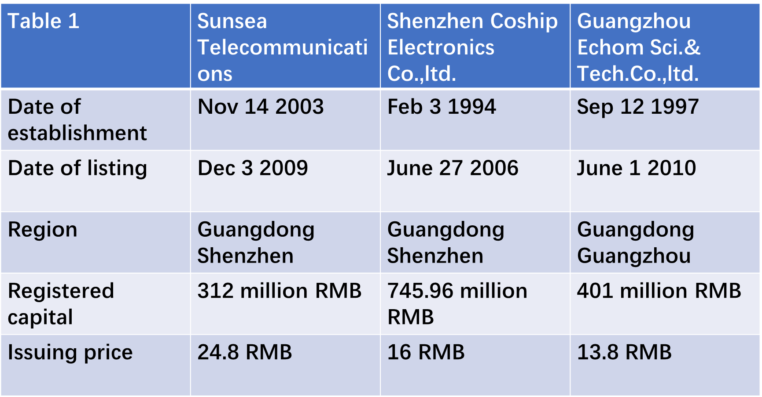In order to see the relative effect of an ESOP on the targeted company compared to the fluctuation of the telecommunication industry as well as the turmoil of the Shenzhen stock market, the author also chose two control groups: two similar listed Guangzhou telecommunication companies in A-share market without ESOPs or other similar motivation plans, and calculated the average ROI similarly (Fang, H., Nofsinger, J. R., & Quan, J. 2015). The information of the two control group companies is included in Table 1 below.

Thirdly, the author chooses the SZCZ stock as the benchmark stock price to see the relative effect of an ESOP compared to the turmoil of the Shenzhen stock market. The author used the ROI of the target company to subtract the ROI of the control group and subtract the ROI of the SZCZ to get the relative ROI of the target company in order to see the relative effect of an ESOP on the target company.

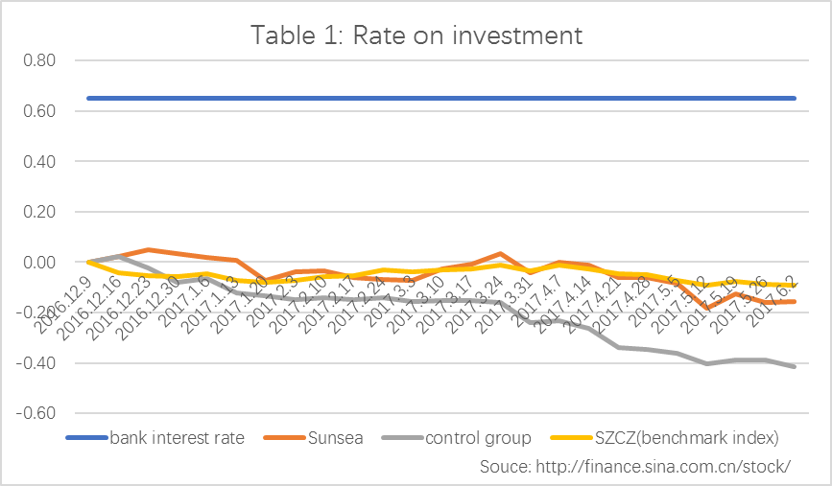If the relative ROI is positive, then ESOP has positive effect on the targeted company, for it offsets the decline of the stock price of the industry and/or the benchmark index, and it promotes the rise of the stock price of the targeted company. If the relative ROI is bigger than the semi-annual bank interest rate 0.65, then it is a rewarding investment.

**Data collection**

Table 1 shows the absolute ROI of the target group, the control group, and the benchmark index. Blue line is the semi-annual bank interest rate 0.65.

Table 2 reveals the percentage of change of the absolute ROI of the three groups.

Table 3 demonstrates the relative change of the ROI of Shenzhen Sunsea company compared to the telecommunication industry, Shenzhen Sunsea compared to the Shenzhen stock market, and the telecommunication industry compared to the Shenzhen stock market.

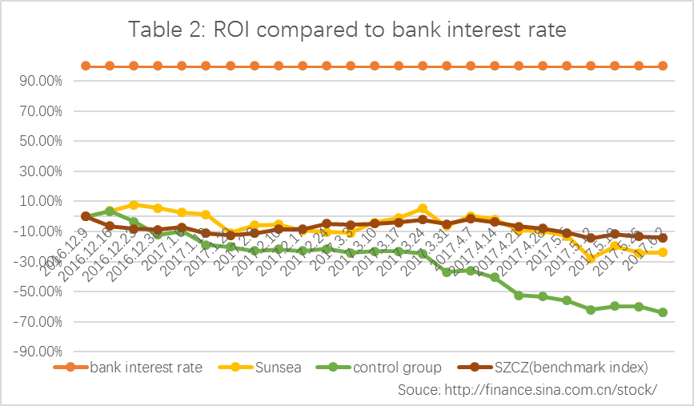Table 4 displays the relative ROI of Shenzhen Sunsea.

**Data analysis**

The absolute ROI of Shenzhen Sunsea telecommunication company from Dec 9th 2016 to June 2nd 2017 equals 0.16.

The relative ROI of Shenzhen Sunsea telecommunication company from Dec 9th 2016 to June 2nd 2017 = ROI (Sunsea)-ROI (control group)-ROI (benchmark index) = (-0.16) - (-0.41) - (-0.09) =0.34

**Result discussion**

During the research period, the author examined the company announcements of Shenzhen Sunsea and the two control group companies. There was no major asset restructuring, such as Merge & Acquisition, among those three companies, nor were there any implementations of equity incentive. Thus, the stock price performance of the target company is mostly related to the implementation of an ESOP. Similarly, the stock price performance of the control group companies is related to the fluctuation of the telecommunication industry, therefore, the average stock price performance of the control group companies may be used to represent the turmoil of the telecommunication industry.

The absolute ROI is 0.16, which includes the telecommunication industry performance as well as the Shenzhen stock market performance during the research period. 0.16 is a positive number, therefore, for Shenzhen Sunsea telecommunication company, investment into an ESOP is rewarding. The relative ROI is 0.34, which eliminates the influence from the fluctuation of the telecommunication industry and the trend of the Shenzhen stock market. 0.34 is positive, thus, ESOP has a positive effect on the target company Shenzhen Sunsea. Nevertheless, 0.34 is smaller than the semi-annual bank interest rate 0.65, which indicates that the effect is modest.

From Table 3, during the research period, the ROI of Shenzhen Sunsea outperformed the control group all the time. This means that within the same industry, ESOP has a positive effect on the stock performance of the targeted company compared to the control groups. Also, 45.8% (11/24) of the ROI of Shenzhen Sunsea during the research period exceeded the benchmark index ROI (excluding the ROI of Jan 27 2017 due to the closure of the Shenzhen stock market on the New Year’s Eve, as well as the first day of the research Dec 9 2016 as the ROI equals 0). This indicates that ESOP has a positive effect on Shenzhen Sunsea stock price performance. Furthermore, nearly 91.7% (22/24) of the observations of the ROI of the control groups minus the Shenzhen stock market are negative, which indicates that the telecommunication industry witnessed a decline during the research period. Two major rises happened in December and from end of February to start of May. One major drop took place in February.

When looking closely at every ROI fluctuation during the research period, as is shown in Table 4, each fluctuation reflects either a telecommunication industry fluctuation or Shenzhen stock market turmoil.

Shenzhen Sunsea released its ESOP draft on December 10, 2016, therefore, its relative ROI boosted in December. On February 23, the first Chinese Enterprise Reform and Development Forum took place in Beijing, which similarly gave out positive signal to the market and boosted Sunsea’s absolute ROI.

On March 21 2017, Sunsea completed its stock purchase from the first market and released a progress bulletin. This signaled its investors that Sunsea was well operated, and may positively boost its relative ROI afterwards.

In April, there was a slump in the A-share market due to the heightened government financial regulation (Cheng 2017), especially on the insurance investment, which discouraged the investment into insurance and discouraged the Shenzhen stock market’s performance on the whole. During the same period, the government set a purchase threshold on the investment into Xiongan real-estate. As a substitute product, investments into the Xiongan stock market were popular. This boosted the cement industry stock performance, and stimulated the Shenzhen stock performance simultaneously. Together, these two major market turmoil lead to the rise of Sunsea’s relative ROI in April.

On May14 and 15, the Belt and Road Forum was held by President Xi in Beijing. The event had direct positive effects on construction, steel, and engine industries compared to the telecommunication industry. This can be shown in Table 3, as the “control group-benchmark index” line dropped consistently in May. What’s more, as a universal currency among the Belt and Road countries, RMB need to stabilize its currency value. Therefore, the People’s Bank of China tightened the monetary policy to balance the budget and stabilize the RMB. This policy put pressure on the stock price. Thus, as a general result, the relative ROI in Table 4 fluctuated in May.

However, as a long-term investment, ESOP is meant to last for more than half a year, which exceeds the research period of this paper. The positive effect of ESOP may not have been fully presented within this short research period. Moreover, one of the major advantages of an ESOP is the tax break and defer payment. Employees can earn future value of the stock tax by investing those money in other financial plans such as the mutual funds. However, there will not be a similar tax break or tax deferment in the China stock market until ESOPs proves effective (Tax benefits expected as China pilots ESOP 2014). Therefore, ESOPs in China may not attract same number of investors and companies, and may not have the same effect as it is in the United States (China: Regulator Allows Employee Stock Ownership Plans 2014). Furthermore, most US investors are fundamental investors, for they focus on the company itself by analyzing its financial statements. Whereas most Chinese investors are technical investors who focus on the return on investment by evaluating the management group as well as the latest market trend. Therefore, Chinese investors are more speculative and not suitable to invest in the long-term rewards of an ESOP.

Correlation is not causation, and ROI of a company may not well present the influence of an ESOP on the company performance. Because the motivation effect of an ESOP on the company is hard to measure and hard to quantify, the author suggests that future research may consider to use questionnaire to measure if employees are motivated or not after buying their companies’ stocks, for the employees are the direct source of the companies’ performance (Chiu, W. C., Hui, C. H., & Lai, G. W. 2007).

**Conclusion**

Comparing to the semi-annual bank interest rate 0.65 in China, the author can reach the conclusion that ESOP has a positive effect on the semi-annual stock price performance for the listed company Shenzhen Sunsea Communication Company, in terms of a medium-term investment. Moreover, Shenzhen Sunsea Communication is a representative ESOP company in the telecommunication industry. Therefore, the success in Shenzhen Sunsea may indicate that ESOP could have a positive effect on the telecommunication industry, too. However, the result is inconclusive due to the short research period, government influence, as well as the numerous indispensable fluctuations of the stock market in China (Meng, R., Ning, X., Zhou, X., & Zhu, H. 2011). And the author suggests that more future research needs to be done to draw a firm conclusion that ESOP has a positive effect on the semi-annual stock price performance for listed company. Moreover, investment involves risk. Buyers beware.

**References**

[1] Belt and road portal. Retrieved from https://eng.yidaiyilu.gov.cn/

[2] Cheng, E. (2017, May 09). Beijing's crackdown on risky debt is throwing Chinese investors for a loop. Retrieved from http://www.cnbc.com/2017/05/08/china-beijing-crackdown-on-debt-spooks-investors.html

[3] China Securities Regulatory Commission. Retrieved from <http://www.csrc.gov.cn/pub/newsite/>

[4] Chiu, W. C. (2003). Employee stock ownership plans and organizational integration among workers in the Peoples Republic of China. Human Resource Management Review, 13(3), 407-421. doi:10.1016/s1053-4822(03)00043-3

[5] Chiu, W. C., Huang, X., & Lu, H. L. (2005). When Marx Borrows from Smith: the ESOP in China. Journal of Contemporary China, 14(45), 761-772. doi:10.1080/10670560500206850

[6] Chiu, W. C., Hui, C. H., & Lai, G. W. (2007). Psychological ownership and organizational optimism amid Chinas corporate transformation: effects of an employee ownership scheme and a management-dominated board. The International Journal of Human Resource Management, 18(2), 303-320. doi:10.1080/09585190601102539

[7] ESOP (Employee Stock Ownership Plan) Facts. Retrieved from http://www.esop.org/

[8] Employee Stock Ownership Plans (ESOPs). Retrieved from <https://www.irs.gov/retirement-plans/employee-stock-ownership-plans-esops>

[9] Fang, H., Nofsinger, J. R., & Quan, J. (2015). The effects of employee stock option plans on operating performance in Chinese firms. Journal of Banking & Finance, 54, 141-159. doi:10.1016/j.jbankfin.2015.01.010

[10] Meng, F., Huang, G., Xu, T., & Feng, W. (2016, Dec). Ninth Proceedings of URP-Related Research at ICB. China Agricultural University Press

[11] Meng, R., Ning, X., Zhou, X., & Zhu, H. (2011). Do ESOPs enhance firm performance? Evidence from China’s reform experiment. Journal of Banking & Finance, 35(6), 1541-1551. doi:10.1016/j.jbankfin.2010.11.004

[12] National Center for Employee Ownership (NCEO): ESOP plans, stock options, restricted stock, phantom stock, and more. Retrieved from http://www.nceo.org/

[13] NRA Explore. Retrieved from <https://home.nra.org/>

[14] Sunseagroup. Retrieved from <http://www.sunseagroup.com/en/default.aspx>

[15] Tax benefits expected as China pilots ESOP. Retrieved from [www.chinadaily.com.cn/business/2014-06/23/content_17608260.htm](http://www.chinadaily.com.cn/business/2014-06/23/content_17608260.htm)

[16] The ESOP Association - Employee Ownership Through Employee Stock Ownership Plans. Retrieved from http://www.esopassociation.org/

[17] (n.d.). Retrieved from http://finance.sina.com.cn/stock/

[18] 27, 2. J. China: Regulator Allows Employee Stock Ownership Plans. Retrieved from <https://www.bna.com/china-regulator-allows-n17179891638/>